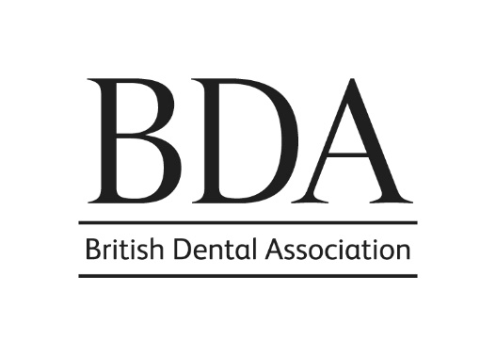
BDA HONOURS & AWARDS

Thank you for requesting a nomination form for your colleague to receive a BDA honour or award. The Honours & Awards Committee would very much like this individual to be considered and would be grateful if the following form could be completed to aid their consideration. Please note, only one nomination form can be considered for an individual.

We realise that not all nominees will have contributions for every section. However, it will strengthen an application if as many sections as possible are completed.

Nominations should have support from Branch/Section/Group or Standing Committee or other professional association.

Please be aware that success in receiving an honour or award is strongly based upon the information you provide in the nomination form. It is anticipated that the nominee may in some instances need to help you complete the form to ensure comprehensive information is provided. At this stage, you are only required to submit the completed nomination form; please do not attach a separate CV. If further information is required, the Committee will request this at a later date.

You may find it useful to look at the relevant pages on the website to get some further general information and to see who has received awards in the past.

Honours and awards are not guaranteed. We would therefore be grateful if you could reiterate this to the individual, if they are aware of their nomination, to avoid any disappointment.

The professional standards of conduct and behaviour of members and staff of the Association are outlined here. Please note we do not accept self-nominations or nominations by a family member. Soliciting and canvessing is also not allowed. The BDA reserves the right to validate all nominations.

Nomination forms may be submitted to: Alison Magee alison.magee@bda.org at any time throughout the calendar year for forwarding to the Committee. Nominations to be considered for next year’s honours and awards must be received by no later than 31 May 2024*. Once your nomination has been considered by the Committee, recommendation will be made to the Principal Executive Committee. You will be informed of its decision in writing and awards will hopefully be presented in 2026 with mutually agreed optional arrangements at an earlier date if requested.

Should you have any queries, please contact alison.magee@bda.org

With many thanks.

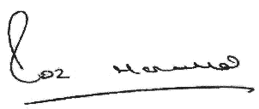

Roz McMullan
Chair, Honours and Awards Committee

* nominations for the Joy Harrild Award should be submitted by 26 April 2024

NOMINATION FORM FOR BDA HONOURS & AWARDS

Nominating Branch /Section / Group/ Committee or professional association (as appropriate)

Name of contact person and office held

Contact details for correspondence
(Address, telephone number and email of contact person)

Personal Details of Nominee

Name of Nominee

Membership Address

Qualifications with relevant dates

BDA Membership – including the date membership commenced

Honour or Award for which they are being nominated (please refer to the attached guidance for categories)

Career Information
Please detail nominee’s sphere(s) of practice, with dates, places and appointments held, and date of retirement (if applicable)

BDA Activity

(i) Please provide details of activity at Branch and Section and/or Group level, including membership of Branch, Council, Group, Committees etc, with dates. Please include details of any outstanding service to Branch, Section and Group or members locally.

(ii) Please provide details of membership of national BDA Committees, Sub-Committees and Working Parties, with dates, offices held etc

(iii) Please provide details of any representation of the Association on outside bodies at national level

(iv) Please provide details of any other special contributions

Other Committee Experience
Please provide details of any involvement with other associated Committees

International Activity
Please provide details of any involvement at international level (eg FDI)

Specialist Societies
Please provide details of memberships with any specialist societies, with offices and dates

Scientific achievements
Please list publication in peer-reviewed journals and any published books and contributions to books as well as any significant successful grant applications and research

Other contributions to professional activity
Please provide details of any other contributions to the profession (eg speaker at Branch and Section meetings, postgraduate courses etc)

Has your nominee contributed to exemplary patient care?
Please provide examples or details

Statement of Support
Please summarise the reasons why the Branch/Section/Group, BDA Committee or professional association is nominating this individual for a BDA Honour or Award (approx 200 words - please continue on a separate sheet if necessary).

Nomination

Please indicate whether the nominee is aware of this nomination

Yes □ No □

Signed: ……………………………………………………… Date: …………………………

Please return the completed form to Alison Magee alison.magee@bda.org by 31 May 2024
(Nominations for the Joy Harrild Award for Young Dentists should be submitted by 26 April 2024)
.
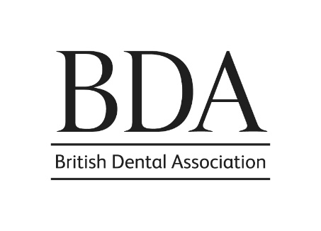

BDA HONOURS AND AWARDS CATEGORIES

BDA PRESIDENT (Honour)
This is the highest office in the Association and the most supreme honour which the Association may bestow.
Eligibility and purpose:
- To honour outstanding service to the Association and UK dentistry
- Any member of the Association is eligible for nomination

HONORARY MEMBERSHIP (Honour)  Considered to be one of the Association’s highest honours; one which is rarely awarded.  Eligibility and purpose:  - A rare honour, which is often bestowed on dignitaries from overseas dental associations  - Distinguished persons who may or may not be members of the Association or of the dental profession | FELLOWSHIP MEDAL (Honour)  Eligibility and purpose:  - To honour distinguished service to the Association and/or dental profession  - Any ordinary member (including a Life Member) of the Association who has:  - been for 20 years continuously an ordinary member of the Association, and  - given exceptional and distinguished service by:  - a sustained, personal commitment to realising the goals of the Association and/or advancing the standing and status of the profession  - gaining the high regard and respect of fellow members of the Association | JOHN TOMES MEDAL (Award)  Eligibility and purpose:  - To honour members of the dental profession or persons distinguished in medical or allied services  - Any person, whether or not otherwise eligible for ordinary membership of the Association  - To honour outstanding services to the dental profession or the Association  - Normally not more than one or two medals would be awarded in one year | LIFE MEMBERSHIP (Honour)  This honour is not usually awarded until after retirement from practice, except in cases of outstanding service.  Eligibility and purpose:  - To honour long and valuable service to the Association, particularly at Branch, Group and local levels, by significant service beyond the regular attendance at meetings and usually by significant representation at national level  - An ordinary member of the Association who has been either:  - for 25 years continuously a member, or  - for 10 years continuously a member who has ceased to practice dentistry and holds no paid dental appointment  - It is anticipated that not more than one or two such awards will be made in any one branch or group within one year and will not necessarily be awarded every year

BDA HONOURS AND AWARDS CATEGORIES

ROLL OF DISTINCTION (Award)  Eligibility and purpose:  - To honour outstanding services to UK dentistry  - Any person, whether or not eligible for membership of the Association  - This award allows non-dentists to be honoured appropriately | AWARD FOR EXCELLENCE (Award)  Eligibility and purpose:  - To recognise any special service at any level of dentistry either nationally or internationally  - In general, this award is reserved for dentists and other persons who have contributed to work in furthering dentistry, the profession, or individuals active in promoting advancements within the dental profession  - Nominations would be sought for practitioners who have demonstrated excellence in any sphere of dentistry - examples of which are:  - oral health promotion  - dentistry in the community  - clinical developments  - new and inclusive approaches to patient-centred care/creating a patient-friendly environment  - development of good practice in any setting  - promoting the profession and practice of dentistry  - business entrepreneurship  This should be considered a contemporaneous award for nominees at any stage of their career. | JOY HARRILD AWARD FOR YOUNG DENTISTS  (Award)  Eligibility and purpose:  - To recognise young dentists who have made a significant contribution to the profession  - Any BDA member young dentist (up to ten years post qualification) who meets at least two of the following criteria:  - have made a significant contribution to the profession, or  - have demonstrated an outstanding commitment to continued training and professional development, or  - have raised the profile of dentistry, or  - have made a contribution to the BDA, or  - have made a positive contribution to wider society through ‘good works’; working with a charity, their local community, or work abroad, or  - have demonstrated professional or clinical leadership qualities

