<town> is in this together

Let’s support each other not do harm

<practice name> appreciates your respect during this challenging time

Our team is doing its best

Your patience and understanding is so important right now

Colleagues have had too much anger and verbal abuse

We can’t take anymore

Today we’re feeling

Please bear with us

Thank you for your kindness

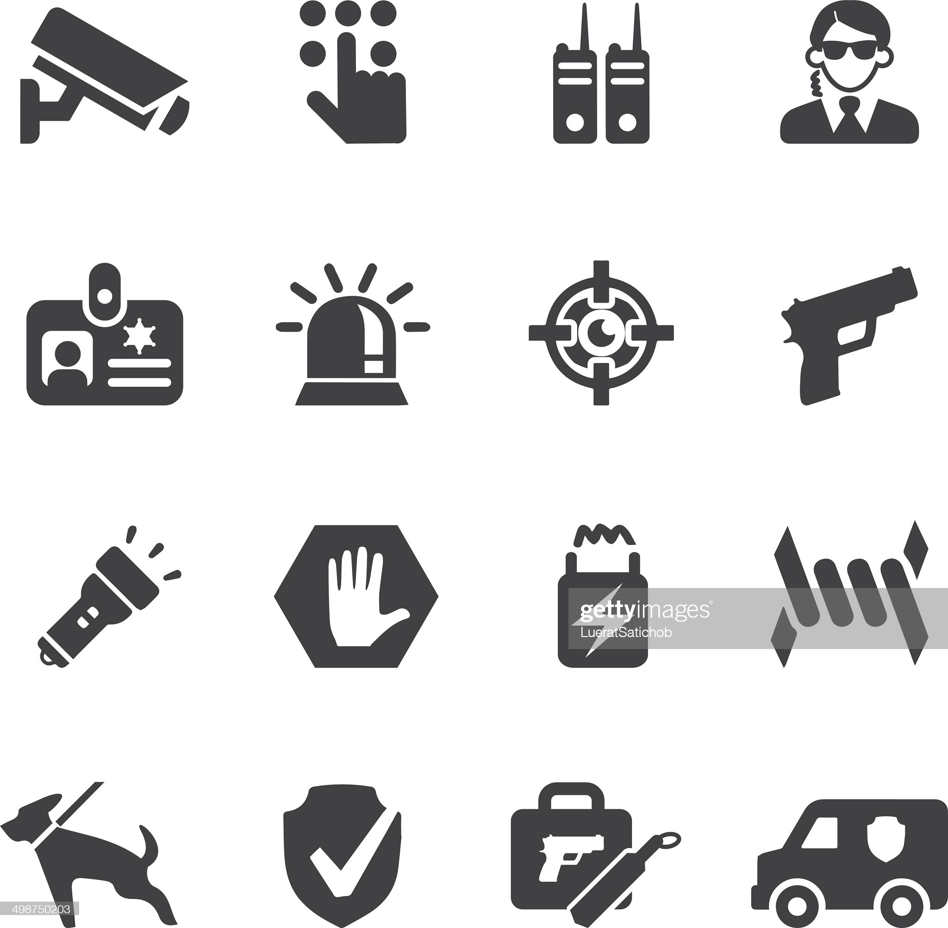

We will not tolerate abuse   
of our staff

Things are tough for everyone   
right now

Please respect our team