Local Services  Face-to-Face event  Information Form | 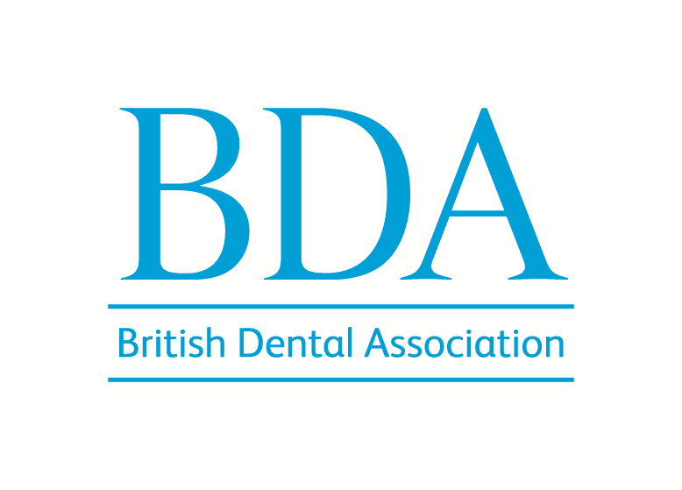
Please complete the following form and send it to our Local Services Team at
branchsectionevents@bda.org. If you have any questions please call 020 7563 4590.

Branch / Section / Division / Young Dentist Group:

Event name:

Date of Event:

Venue: (please include full postal address)

Venue capacity:

Timings of Event

Registration -

Refreshments -

Start of lecture/s -

End of lecture/s -

End of event -

Food/buffet/meal -

AGM timings, if applicable -

Any other timings we should be aware of -

Refreshments/food/buffet/meal

Please confirm what type of refreshments or food you will be providing and if you require us to collect dietary requirements.

Prices:

BDA members:
Non-member dentists:
DCPs:

If you have any special offers or early bird booking rates please provide details below and (if applicable) when these will expire.

Number of CPD hours:

PLEASE NOTE: We need development outcomes, aims, learning objectives and learning content for each speaker if you are organising a face-to-face event with more than one speaker on different topics.

Development outcome/s:

(please indicate which letter/s the content relates to – ie: A B C D)

Click here for more information about CPD and Development outcomes
https://www.gdc-uk.org/education-cpd/cpd/enhanced-cpd-scheme-2018

PLEASE NOTE: The aims, learning objectives and learning content each have a character limit of 400 (letters and spaces), so it fits within our CPD certificate template.

Aims:
Overview of what the activity will achieve.
Maximum of 400 characters (letters and spaces, not words).

Learning objectives:
Maximum of 400 characters (letters and spaces, not words).

Should fulfill the aim. By the end of this activity, the participant should be able to…

Learning content:
Maximum of 400 characters (letters and spaces, not words).
A short summary of the content of the lecture.

Speaker(s):

Name:

GDC number (if applicable):

Speaker biography (no more than 75-100 words):

Speaker photo (please attach to email):

Sponsors and exhibitors
Please provide the name of the company/companies exhibiting at or sponsoring the event (if applicable)

Any text / company information you want us to include on the web page

Logo/s (if applicable). Please attach to email

Event contact:
Please provide name and email address (if we have any questions):

Social events / Dinners
Does your event include a social event, such as a Dinner? Yes No
If ‘yes’, we can take the bookings for this from those working in the dental industry and those who don’t. Please provide details.

Do you need to know dietary requirements by a certain date?

Is there a deadline for bookings?

Do you need to prepare a table plan? Yes No

If ‘yes’, we can provide you with booking data for this purpose - when do you need the guest names by?

Is there anything else we should know about the social event or Dinner?

Postal mailing

Does the event postal mailing? Yes No
NB: The cost for any postal mailings would be charged back to you. Please let us know what you would like to do and we can discuss the number of people to be mailed and the likely cost.

Please return to: Local Services Team – branchsectionevents@bda.org

