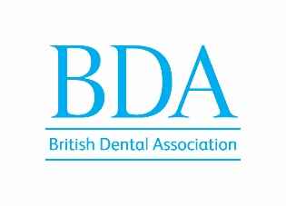

GDPC Member – EXPENSES CLAIM

LDC Officials’ day
Friday 1 December 2023

Name (please print) _______________________________ ___

Address in full ________________________________________________________
(including county
and postcode) ___________________________________ _____________________

_________________________________ _______________________

Tel No ___________________________________ _____________________

Air Fare £ _________________________________

Standard Class Return Rail Fare £ _________________________________

Any sleeper charges £_________________________________

Car mileage (45p per mile) £_________________________________

Car parking £_________________________________

Hotel costs necessarily incurred £_________________________________
(up to £200.00 inc vat - one night only)

Claim if staying with friends/relatives £_________________________________
(£25 one night)

Dinner subsistence applicable for overnight stay £_________________________________
(£25 one night)

Total expenses claimed £_________________________________

I claim payment of the above expenses necessarily incurred in attending LDC Officials’ day 2023. I am not claiming reimbursement from any other source.

Signature Date __________

Please complete the box below so expenses can be paid directly into your bank account

Sort code
Account number
Account name

Please complete this form and submit by email (with copies of receipts) to
Alex Cenic, Policy Officer, BDA alexandra.cenic@bda.org
(Tel: 020 7563 4158)

