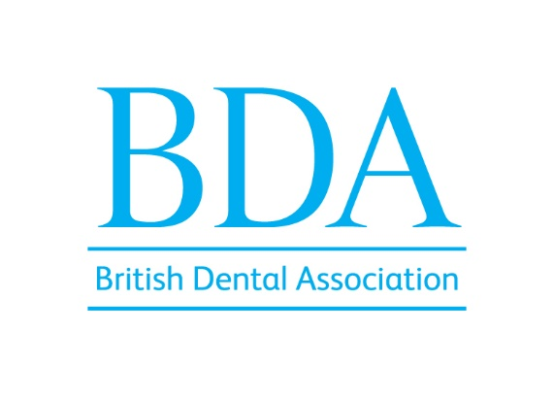
Declaration of Interests

The BDA needs to be aware of possible conflicts of interest between the organisation and its officers and directors. As a director/officer of the BDA you are asked to address the following points and to keep them under regular review.
1 Please review the latest version of the BDA's Conflict Policy.
2 Having done so, please list below all the roles, offices, positions, titles, and connections you (or a close relative) currently hold which have a connection with dentistry or the BDA regardless of whether you believe they might give rise to a conflict of interest.
3 Please note that the information you provide in response to question 2 above will appear on the BDA website and so be accessible to the public.
4 The Audit Committee will review the information you have provided and confirm whether any potential conflict of interest arises which needs to be declared and taken into account in any BDA committee meeting (including of the PEC and it's sub committees).
5 Please be careful to keep the information you have provided in response to question 2 under review and notify stephen.skelton@bda.org immediately should there be any change to it.

Declarations of interest for Nick Marshall:
BDA PEC member
Dental associate at InDental Fewster Square, part of Riverdale Healthcare
Member of the Gateshead and South Tyneside Local Dental Committee
Educational Supervisor for foundation therapists for Health Education England North East

